Extending the Active Directory Schema for Configuration Manager (SCCM/MECM)
Why this matters: Extending the schema allows ConfigMgr to publish site information in AD and enables features like automatic site assignment.
Safety note: Schema changes are forest-wide and additive (you can’t roll them back). The tool is designed to be safe and is typically non-disruptive, but always perform during a maintenance window if possible.

Step 1 — Locate extadsch.exe
- In the mounted media, browse to:
- <MediaDrive>:\SMSSETUP\BIN\X64
Examples: C:\Program Files\Microsoft Configuration Manager\cd.latest\SMSSETUP\BIN\X64.
- Confirm extadsch.exe is present.
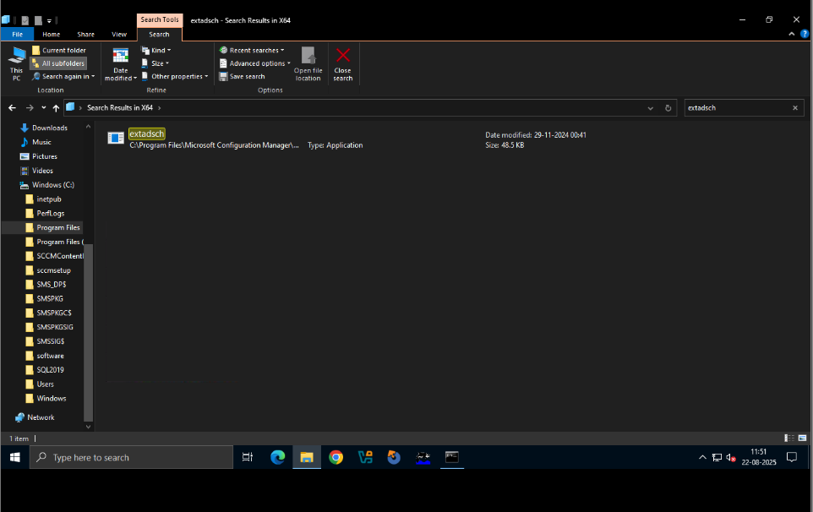
Step 3 — Open an Elevated Console
- Open Command Prompt or PowerShell Run as Administrator.
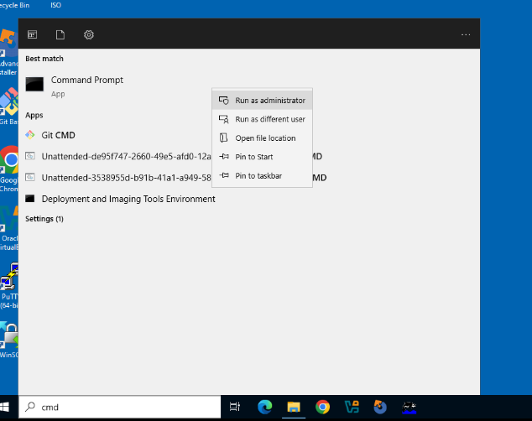
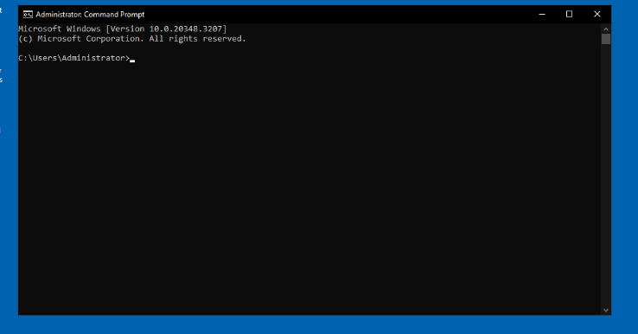
cdStep 4 — Navigate to the X64 Folder on the Media
- CMD:
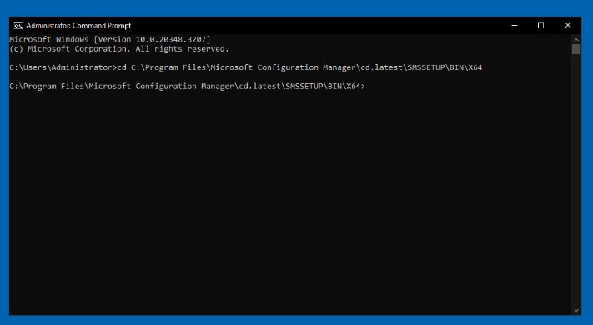
Step 5 — Run the Schema Extension
- CMD:
- extadsch.exe
- If prompted by UAC, click Yes.
- The tool runs quickly and writes a log to the system drive.
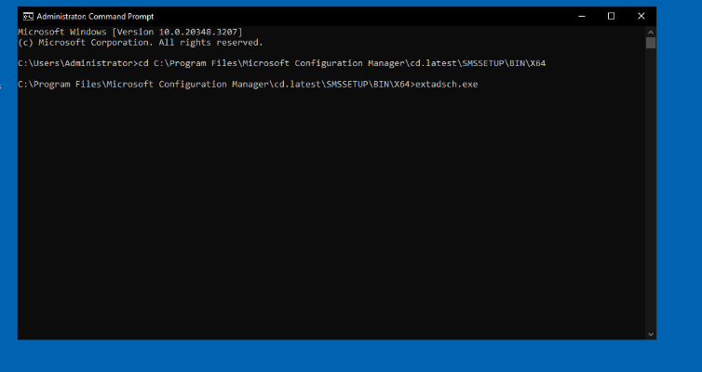
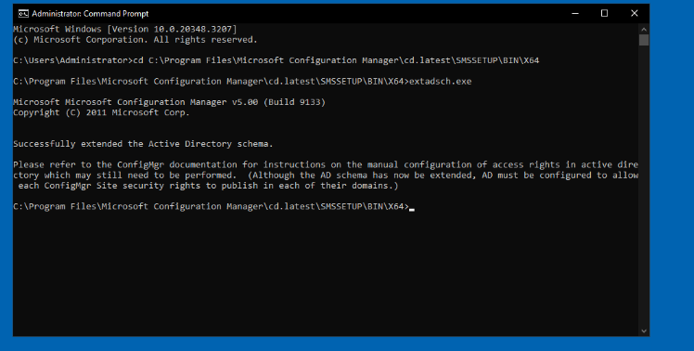
Step 6 — Verify the Log (C:\ExtADSch.log)
- Open the log file from the root of your system drive (usually C:):
- notepad C:\ExtADSch.log
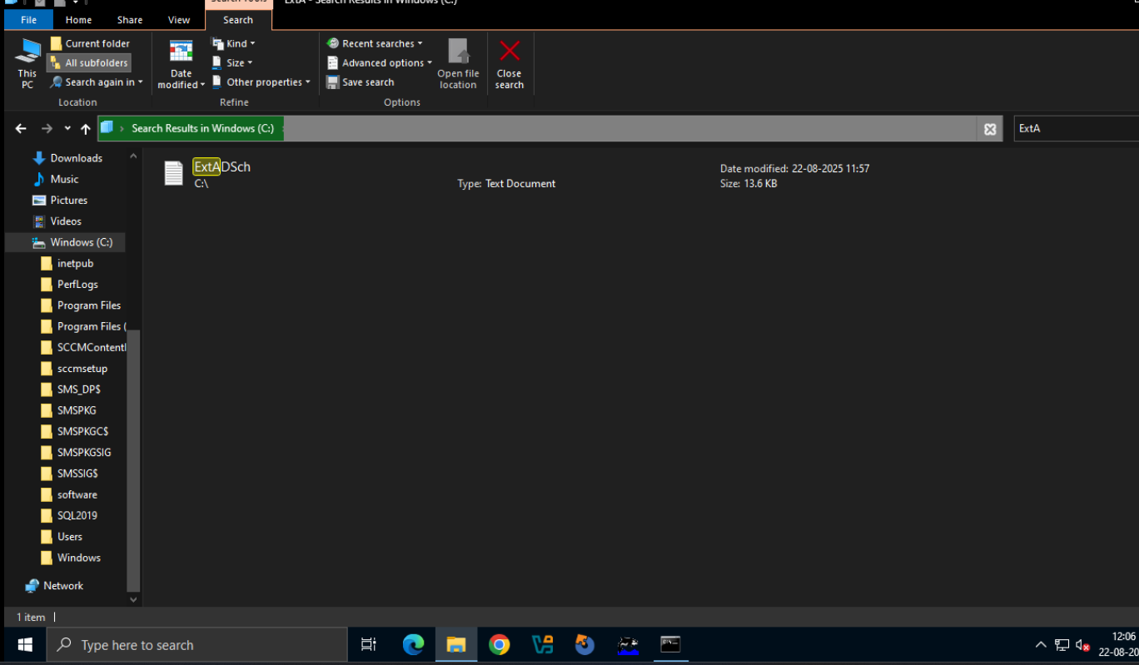
- Confirm it contains a success entry like:
- Successfully extended the Active Directory schema.
- Common informational lines include classes/attributes added; warnings may indicate objects already exist (that can be normal if the schema was extended previously).
